Carlos Alberto Barriga Gámez 20222020179

Cristian Santiago López Cadena 20222020027

**1. Project Description:**

The project consists of the development of monolithic software for an online store. For this, it was decided to use the Amazon online store as a base to create similar software. In terms of technical decisions, the project was limited to the processes of purchasing items on the website and the appearance of the items purchased by the user within a tab called purchased items.

The companies that would use this software have a business model focused on the sales of various items through the Internet.

Concerning interested parties, we consider that the main interested parties in software with these characteristics are the owners of sales companies that intend to expand into online sales and all users who will benefit from being able to buy online. Likewise, we think that students in training can find in this project a tool to complement their knowledge through the review of software currently used by different companies.

Now, among the tools necessary to develop this software, and taking into account that it will be a monolith, it was decided to use Python for the development of the back-end together with the fast-api framework. For the graphical interface, it was decided to use HTML, CSS, JavaScript, Apache server, and Django framework. Finally, for the database, the SQLAlchemy software will be used, since it allows managing database relationships with a syntax similar to that of the programming language.

**2. User Stories:**

**-** UH0: As Amazon, I want a platform where I can sell the different products that I offer to anyone.

1. Página principal

* UH1: As Amazon, I want my company logo to be seen on the main page, to show the products that I consider relevant to the customer and a banner for ads. I also want an option so that the buyer can log in or register in case of that it is not, and thus be able to identify the buyer in the future.
* UH2: As a buyer, I want to access the main window and be able to select the product I want to buy
* UH3: As a buyer, I want to see the products in the main interface, with name and price, and also an image to identify it more easily and thus select the option that I consider appropriate.
* UH4: As Amazon, I want the application not to show those products that are out of stock.

1. Proceso de pago y envió del producto

* UH5: As Amazon, I want it to be verified at the time of payment that the user or buyer has identified themselves as a user of the application and if not, force them to identify themselves.
* UH6: As a buyer, I want to be able to buy more than one unit of a product and be able to see the total price.

1. Función de búsqueda y filtrado

* UH7: As a buyer, I would like to have a search bar in which I can search for the product I want.
* UH8: As a buyer, I want to be able to use different filters and more easily access the product I want.
* UH9: As a buyer, I want to be able to organize the order in which I want the products to be displayed after a search.
* UH10: As Amazon, I want to provide a way to search for products by name, where once the product is searched, the searched product and similar products that may interest the buyer are displayed on a page.

1. Agregar productos para vender

* UH11: As Amazon, I would like to be able to add information about the products that are for sale such as their name, current stock, main characteristics, department to which the product belongs, price, description, images of the product, and store that sells the product.
* UH12: As Amazon, I want to show a preview of the products where you can see an image of the product, the name, the price, and a button to make the purchase.
* UH13: As Amazon, I want the preview to go to a main view in which all the details of the product are seen but the purchase button is maintained.

1. Funciones de un usuario identificado

* UH14: As an end user I want to be able to see all the purchases I have made in the application

**3. Diagrams UML**

* **Activity Diagram Login**

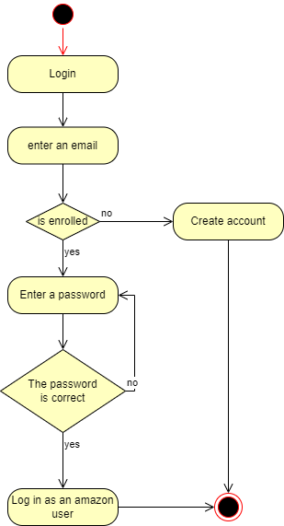

* **Activity Diagram Payment_Process:**

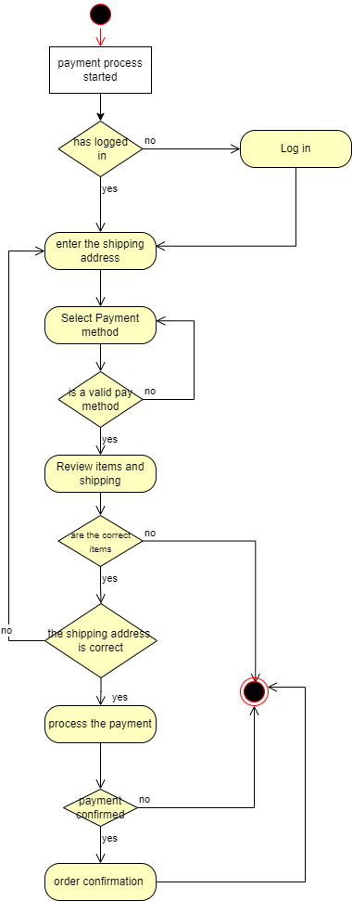

* 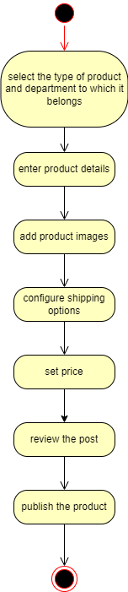**Activity Diagram Sell_Product**
* **Deploy Diagram Monito**

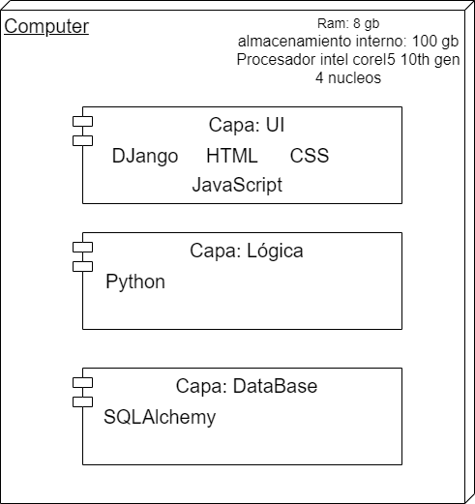

* 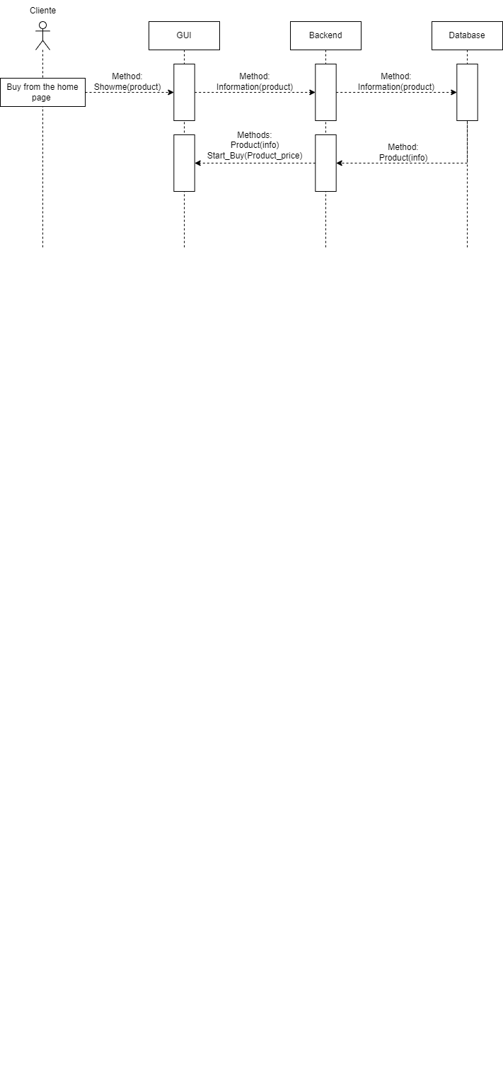**Sequence Diagram Buy**
* 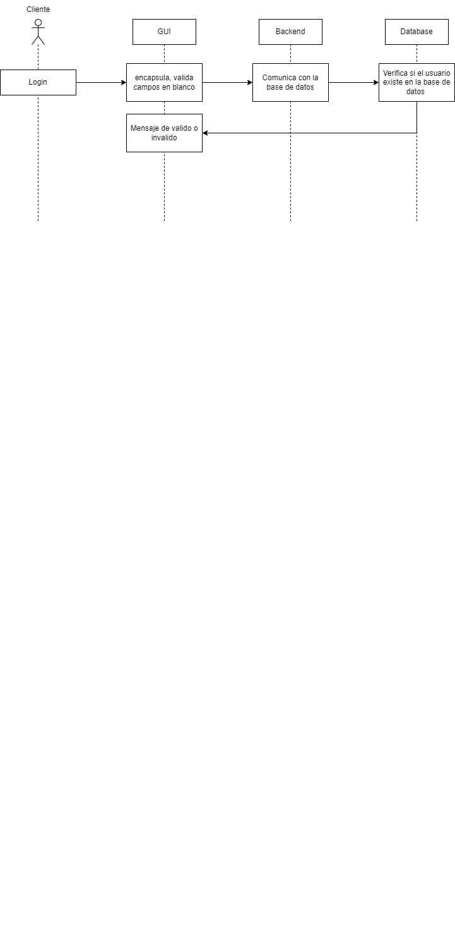**Sequence Diagram Login**
* **Sequence Diagram Payment**

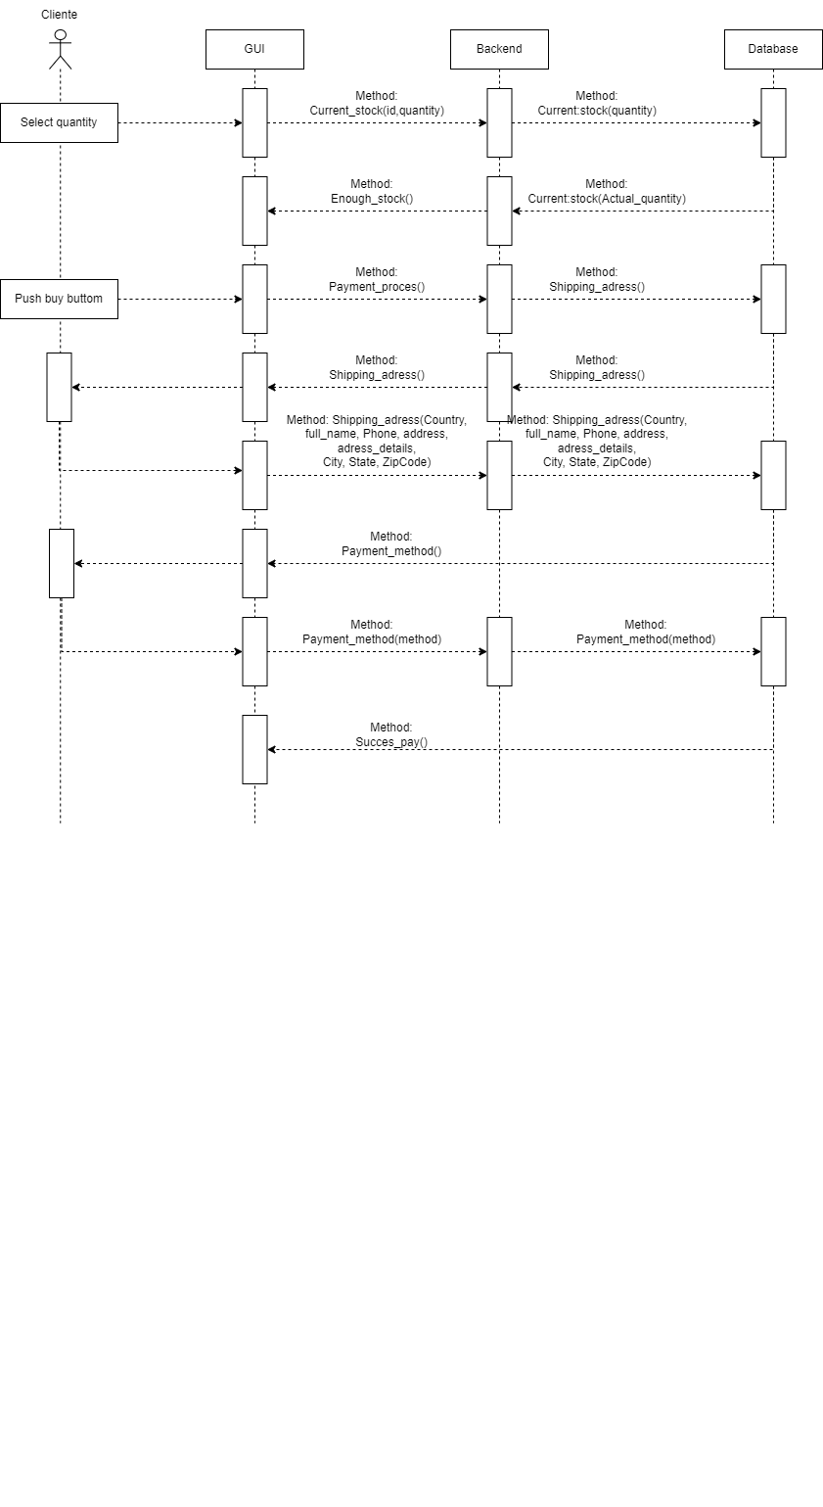

* **Sequence Diagram Product_Post**

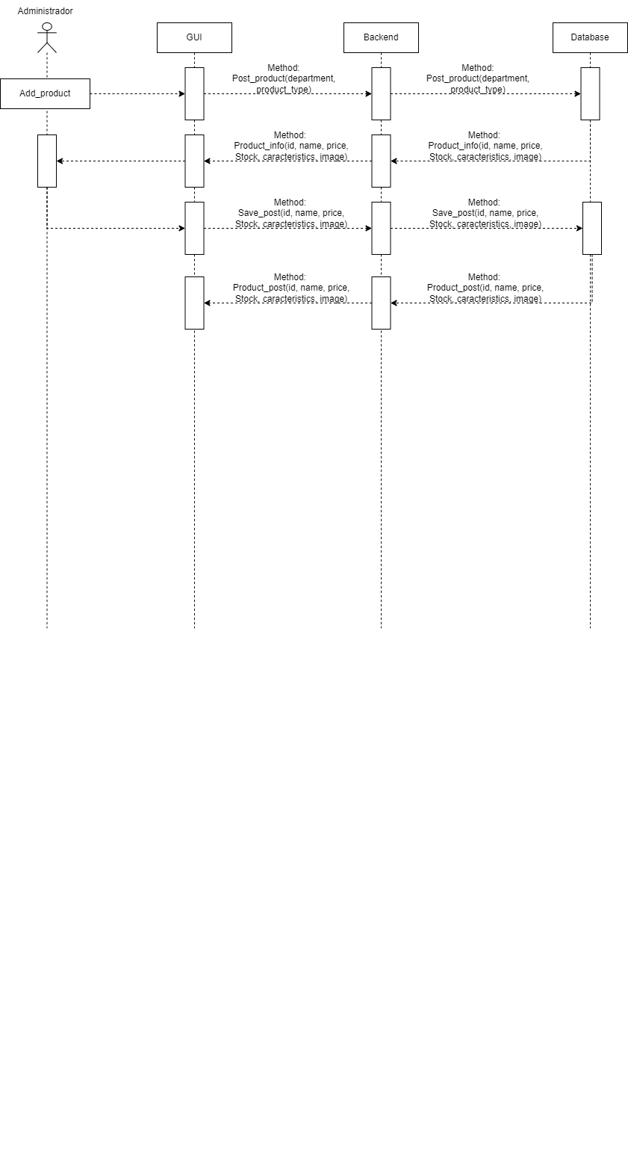

* **Sequence Diagram Search_Product**

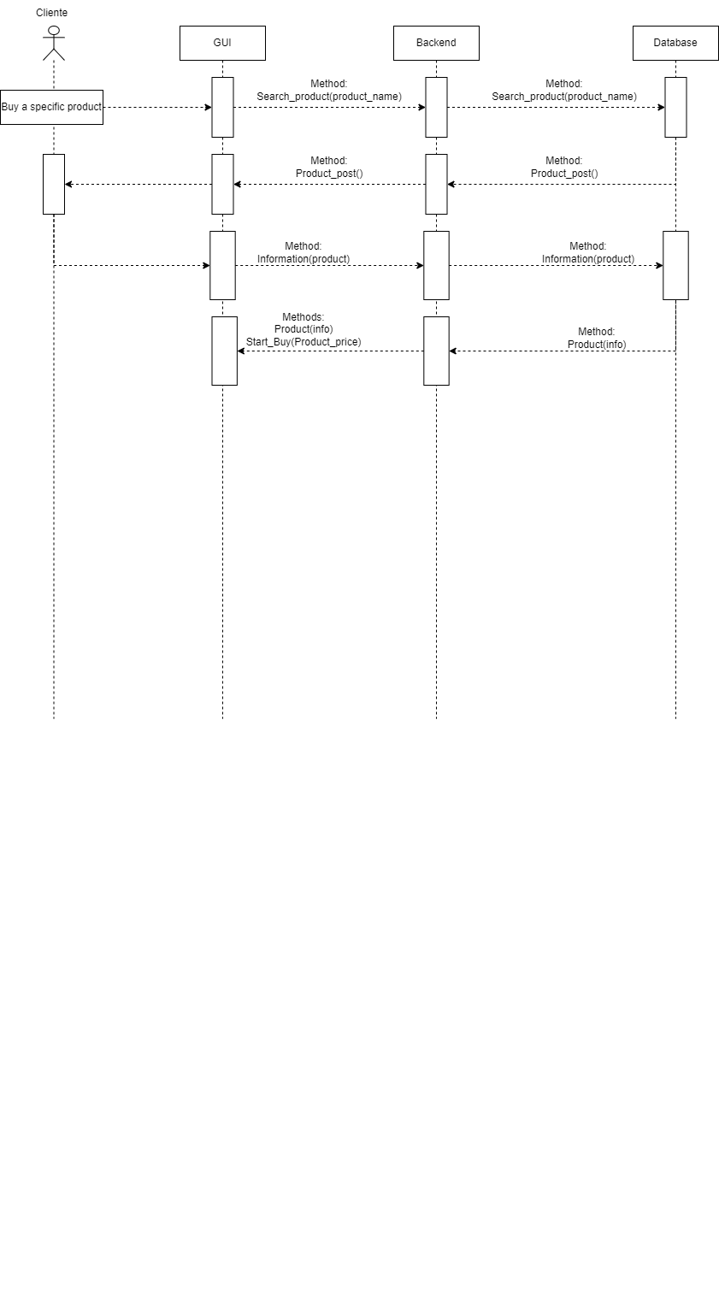

**4. CRC Cards**

|  |  |
| --- | --- |
| Client | |
| Responsability | Collaborator |
| * Decide the product you want. * Select the filters so you can find the product you want. * Fill out the purchase form * Buy products | Product  Pay |

|  |  |
| --- | --- |
| Product | |
| Responsability | Collaborator |
| * Have an identifier. * Have a name. * Have an image. * Have a price. | Client |

|  |  |
| --- | --- |
| Admin | |
| Responsability | Collaborator |
| * Add products to sell | Product  Interface |

|  |  |
| --- | --- |
| Pay | |
| Responsability | Collaborator |
| * Take the user's data to register your purchase. * Remove products that have already been paid for from available inventory. * Assign the product to the user's purchases | Product interface  Product  Purchases interface  Client |

|  |  |
| --- | --- |
| Principal_Interface | |
| Responsability | Collaborator |
| * Show the products available to the user. * Show products that correspond to the user's filters. | Product  Product interface  Purchases interface  Client |

|  |  |
| --- | --- |
| Product_Interface | |
| Responsability | Collaborator |
| * Show the selected product with the price, image, and name. * Generate the purchase form when the user presses a purchase button. | Product  Client |

|  |  |
| --- | --- |
| Purchases_Interface | |
| Responsability | Collaborator |
| * Show the purchased products with the price, image and name. | Product  Client |